


PENINSULA COLLEGE
BA (HONS) ACCOUNTING & FINANCIAL MANAGEMENT STUDIES

MODULE ASSIGNMENT

YAP CHER YAN
040925100668
s4543325
UOGBAFMS2025090007

STUDENT NAME, :
NRIC&ID NO.

LECTURER NAME :
Mr Nicholas Adrian Suppiah

AC5104 Data Analytics and Visualisation
MODULE CODE & :
TITLE

COHORT : Cohort 57

SUBMISSION DATE :
May 2026

Table of Contents
No | Contents | Page
1.0 | Introduction | 3
2.0 | Dashboard Design and Features | 4
3.0 | Target Users and Purpose | 5
4.0 | Usefulness and Benefits | 6
5.0 | Limitations and Areas for Improvement | 7
6.0 | Conclusion | 8
7.0 | References | 9-11
8.0 | Appendix | 12-16
9.0 | Dashboard Link | 17

1.0 Introduction

In the era of big data, dashboards have become essential tools in business, accounting, and finance for analyzing and communicating complex datasets. The pharmaceutical industry generates vast amounts of financial and operational data, including revenue, Research and Development (R&D) Expenses, and stock performance. Dashboards enable decision-makers to interpret this data more efficiently, supporting future strategic planning and decision-making processes. This paper evaluates the practicality of the Pfizer and GlaxoSmithKline plc (GSK plc) pharmaceutical industry dashboards. These dashboards visualize key performance indicators (KPI), including revenue trends, R&D expenditures, average stock price, and R&D intensity. The evaluation focuses on analyzing the dashboard's effectiveness in supporting decision-making, enhancing data visualization, and providing real-time insights. It also critically assesses its limitations based on relevant academic literature.

2.0 Dashboard Design and Features

This dashboard displays comparative data for Pfizer and GSK plc pharmaceutical companies over five years. In terms of visual design, it employs a clean layout with neutral backgrounds and contrasting colours to differentiate data categories. For example, blue represents Pfizer, red represents GSK plc, and green highlighting boxes highlight KPI, such as total revenue and average stock price. This colour scheme effectively enhances overall readability and helps users quickly distinguish variables, adhering to the basic principles of effective data visualization. The dashboard integrates different chart types to display various data. Line charts are used to present trends over time, such as revenue growth and stock price changes. Bar charts are used to compare R&D expenses between different companies. Additionally, the dashboard visualizes a calculated R&D intensity metric (R&D expenses /revenue) to provide deeper analytical insights. The KPI displayed at the top of the dashboard allow users to quickly grasp the overall picture before viewing detailed charts. Research indicates that dashboards combining summary metrics with detailed visualizations help improve users' data comprehension and interpretation efficiency. (Zhuang et al., 2022). Interactivity is another key feature of this dashboard. Users can select specific companies or time ranges using filters, enabling personalized data analysis. This interactive feature allows users to explore data in a more flexible way, rather than being limited to static displays. According to research, interactive dashboards allow users to dynamically explore data, thereby increasing user engagement and further enhancing decision-making performance. (Rahman et al., 2025).

3.0 Target Users and Purpose

The primary users of this dashboard include Chief Financial Officers (CFO), financial analysts, and investors. While the purposes for which these groups use the dashboard differ, they are interconnected. CFO use the dashboard to monitor the company's financial performance, assess R&D spending, and support budget decisions. Since R&D expenses is a significant and costly component in the pharmaceutical industry, a clear view of expenditures and returns is crucial for sound financial planning. Financial analysts use the dashboard to compare and analyze different companies, identifying trends and performance differences. For example, analysts can compare revenue growth rates and R&D intensity to determine the efficiency of a company's innovation investments. Investors, on the other hand, use the dashboard to evaluate a company's overall performance, leading to more informed investment decisions. Among these indicators, stock price trends and revenue performance are particularly important to investors. This dashboard is useful for these users because it provides timely and structured information. According to research, pharmaceutical companies rely heavily on high-quality data and systematic evaluation processes when making decisions. (Bujar et al., 2020). By integrating multiple data sources into a single interface, dashboards not only improve information transparency but also help users make data-driven decisions more easily.

4.0 Usefulness and Benefits

A key advantage of this dashboard lies in its ability to support decision-making. It presents financial and operational metrics in a clear and structured manner, enabling managers to quickly assess the company's overall performance. For example, comparing R&D intensity provides deeper insights into the efficiency of resource allocation for innovation. This is particularly important in the pharmaceutical industry, where R&D plays a crucial role in building competitive advantage. Furthermore, big data analytics is widely recognized as a significant driver for improving decision-making quality in the healthcare and pharmaceutical industries. In addition, the dashboard excels in data visualization. It transforms complex numerical data into intuitive graphical forms such as line charts and bar charts, making it easier for users to understand data patterns and trends. Compared to traditional numerical tables, this visualization significantly enhances data communication, allowing users to interpret information more efficiently. Interactive dashboards have also proven to increase user engagement and promote organizational understanding and decision optimization by making key insights more accessible. Another important advantage is its comparative analysis capabilities. The dashboard allows users to compare the performance of multiple companies across different metrics, providing a more comprehensive performance view, facilitating benchmarking, and helping organizations identify their strengths and weaknesses. According to research, structured data analysis plays a crucial role in assessing the benefits and risks of pharmaceutical decisions, and this dashboard, by presenting comparative data in a clear and easy-to-understand manner, makes this analytical process more efficient. (Kürzinger et al., 2020). Finally, the dashboard's comparison capabilities further enhance its usability. By simultaneously analyzing the performance of multiple companies, users can benchmark performance and identify overall industry trends. This is significant for strategic decision-making, such as supporting investment planning and competitive landscape analysis.

5.0 Limitations and Areas for Improvement

While this dashboard possesses certain practicality, it still exhibits some limitations. One major limitation lies in its over-reliance on historical data. While the dashboard can clearly and effectively display past trends, using outdated or incomplete data can lead to inaccurate conclusions. Therefore, ensuring data quality and integrating data from multiple data sources remains a significant challenge in the context of big data. Another limitation of this dashboard is its potential for oversimplifying complex data. While visualization makes data easier to understand, it can also obscure important details. For example, simple trend lines may fail to capture external factors influencing performance. Furthermore, the dashboard's over-reliance on descriptive analytics not only lacks predictive insights but also limits the value of the analysis. Additionally, in terms of usability, too many options or a complex layout can confuse users. According to research, an effective dashboard should strike a balance between functionality and simplicity to ensure usability. Moreover, improvements such as clearer labels, more logical layout organization, and providing user guides can effectively enhance the overall user experience. (Jeffries et al., 2020).

6.0 Conclusion

In conclusion, the pharmaceutical industry dashboard developed in this project is a valuable tool for visualizing complex data and supporting decision-making. The dashboard's strengths lie in its clear design, diverse visualization methods, and interactive features, all of which enhance data interpretation and user engagement. This dashboard is particularly helpful to CFO, financial analysts, and investors, as it provides timely and structured information on financial performance and R&D investment. However, the dashboard also has some shortcomings, and addressing these shortcomings would further improve its overall effectiveness and enhance its value as a decision support tool. Overall, this dashboard demonstrates the crucial role of data visualization in the pharmaceutical industry and highlights its significant potential to transform big data into actionable insights.

7.0 References
Bujar, M., McAuslane, N., Connelly, P., & Walker, S. R. (2020). Quality decision-making practices in pharmaceutical companies and regulatory authorities: current and proposed approaches to its documentation. Therapeutic innovation & regulatory science, 54(6), 1404-1415.
GSK. (2021). Annual report 2020. GSK. https://www.gsk.com/media/sp5jw3t1/annual-report-2020.pdf
GSK. (2022). Annual report 2021. GSK. https://www.gsk.com/media/vpeltsvw/annual-report-2021.pdf
GSK. (2023). Annual report 2022. GSK. https://www.gsk.com/media/ryjnw2s3/annual-report-2022.pdf
GSK. (2024). Annual report 2023. GSK. https://www.gsk.com/media/iwxac4h1/annual-report-2023.pdf
GSK. (2025). Financial statements 2024. GSK. https://www.gsk.com/media/kqspo2ak/financial-statements-2024.pdf
GSK. (2026). Financial statements 2025. GSK. https://www.gsk.com/media/immdjzop/financial-statements-2025.pdf
Jeffries, M., Gude, W. T., Keers, R. N., Phipps, D. L., Williams, R., Kontopantelis, E., ... & Ashcroft, D. M. (2020). Understanding the utilisation of a novel interactive electronic medication safety dashboard in general practice: a mixed methods study. BMC Medical Informatics and Decision Making, 20(1), 69.
Kürzinger, M. L., Douarin, L., Uzun, I., El-Haddad, C., Hurst, W., Juhaeri, J., & Tcherny-Lessenot, S. (2020). Structured benefit–risk evaluation for medicinal products: review of quantitative benefit–risk assessment findings in the literature. Therapeutic Advances in Drug Safety, 11, 2042098620976951.
Pfizer Inc. (2021). Annual report 2020 (Form 10-K). Pfizer. https://s206.q4cdn.com/795948973/files/doc_financials/2020/AR/PFE-2020-Form-10K-FINAL.pdf
Pfizer Inc. (2022). Annual report 2021 (Form 10-K). Pfizer. https://s206.q4cdn.com/795948973/files/doc_financials/2021/ar/PFE-2021-Form-10K-FINAL.pdf
Pfizer Inc. (2023). Annual report 2022 (Form 10-K). Pfizer. https://s206.q4cdn.com/795948973/files/doc_financials/2022/ar/PFE-2022-Form-10K-FINAL-(without-Exhibits).pdf
Pfizer Inc. (2024). Annual report 2023 (Form 10-K). Pfizer. https://s206.q4cdn.com/795948973/files/doc_financials/2023/ar/2023-10k.pdf
Pfizer Inc. (2025). Annual report 2024 (Form 10-K). Pfizer. https://s206.q4cdn.com/795948973/files/doc_financials/2024/ar/10K_Final.pdf
Pfizer Inc. (2026). Annual report 2025 (Form 10-K). Pfizer. https://s206.q4cdn.com/795948973/files/doc_financials/2025/ar/10-K-without-Exhibits.pdf
Rahman, M. A., Alam, M. S., & Mrida, M. S. H. (2025). How interactive dashboards improve managerial decision-making in operations management. American Journal of Advanced Technology and Engineering Solutions, 1(01), 122-146.
Yahoo Finance. (2026). GSK plc (GSK) historical data. Yahoo Finance. https://finance.yahoo.com/quote/GSK/history/
Yahoo Finance. (2026). Pfizer Inc (PFE) historical data. Yahoo Finance. https://finance.yahoo.com/quote/PFE/history/
Zhuang, M., Concannon, D., & Manley, E. (2022). A framework for evaluating dashboards in healthcare. IEEE transactions on visualization and computer graphics, 28(4), 1715-1731.

8.0 Appendix

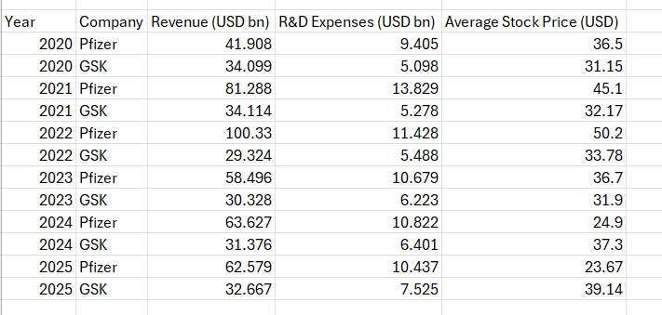

Appendix 1: Excel Dataset

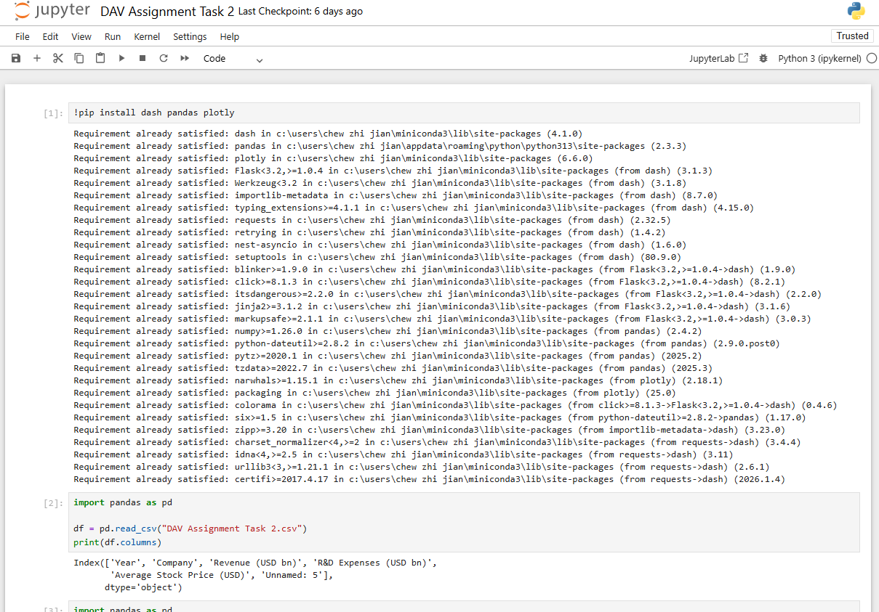
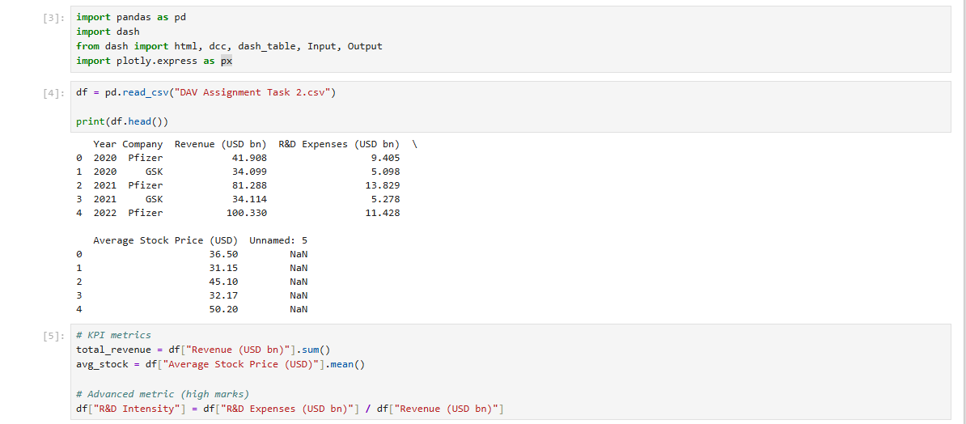
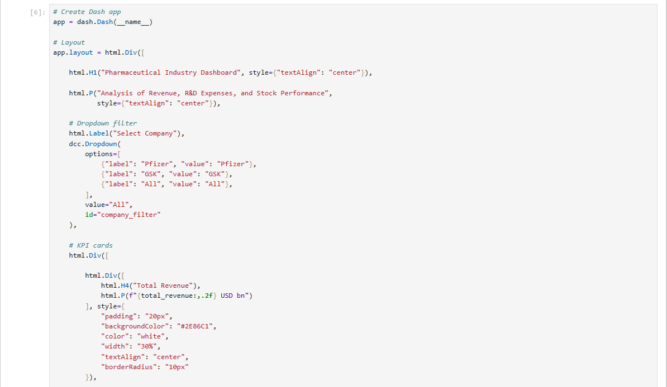
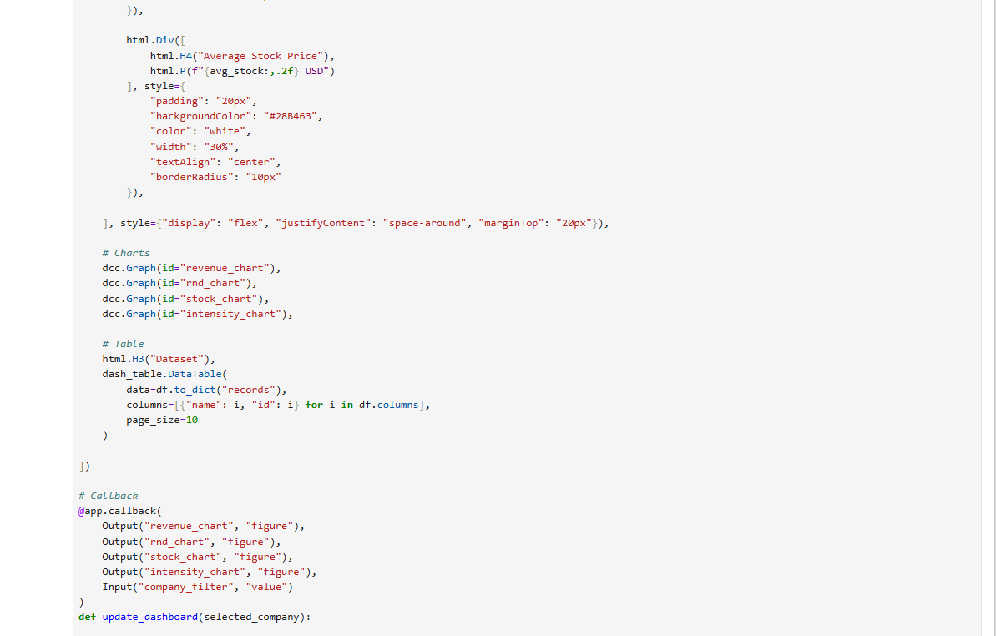
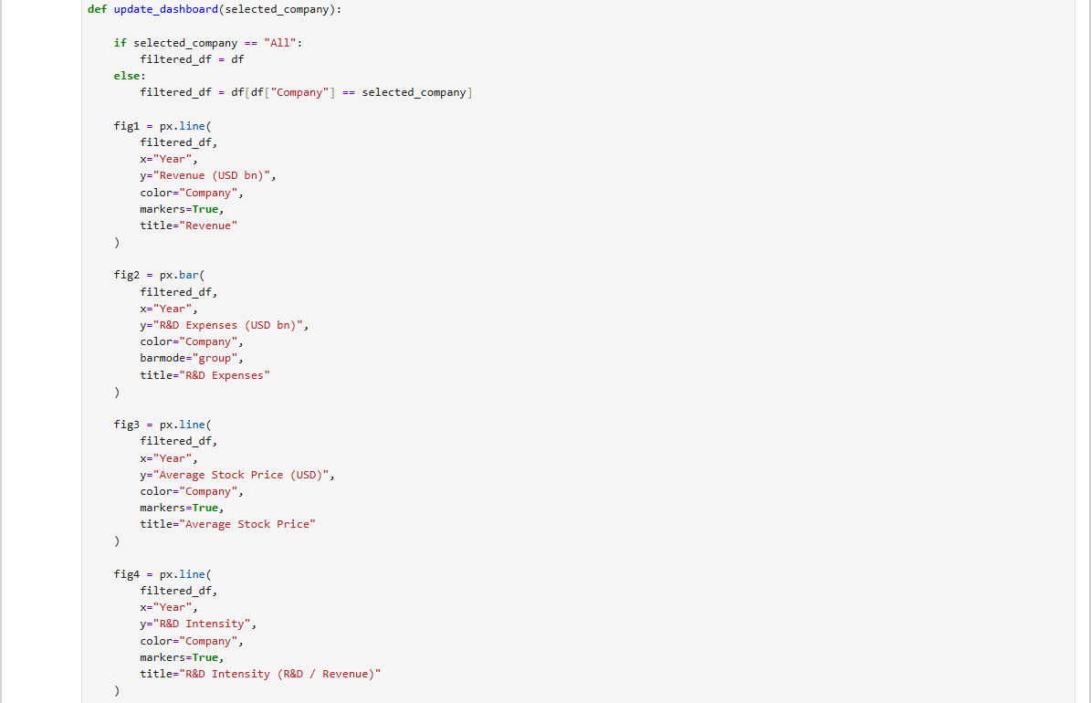
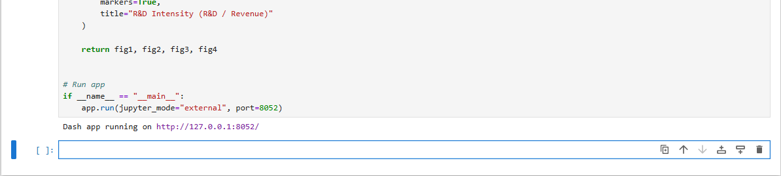
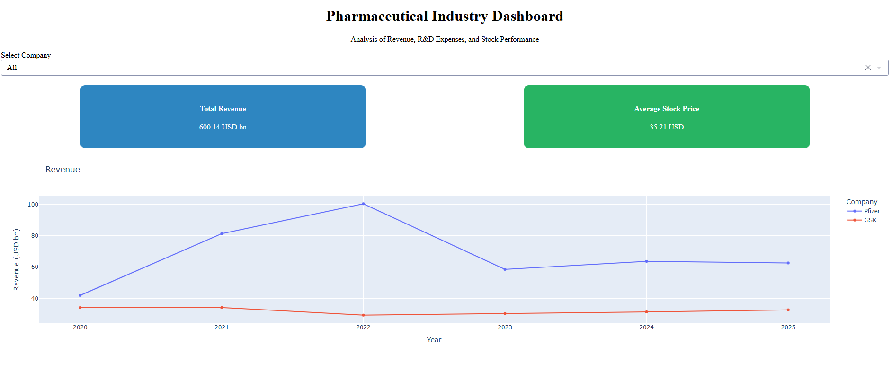
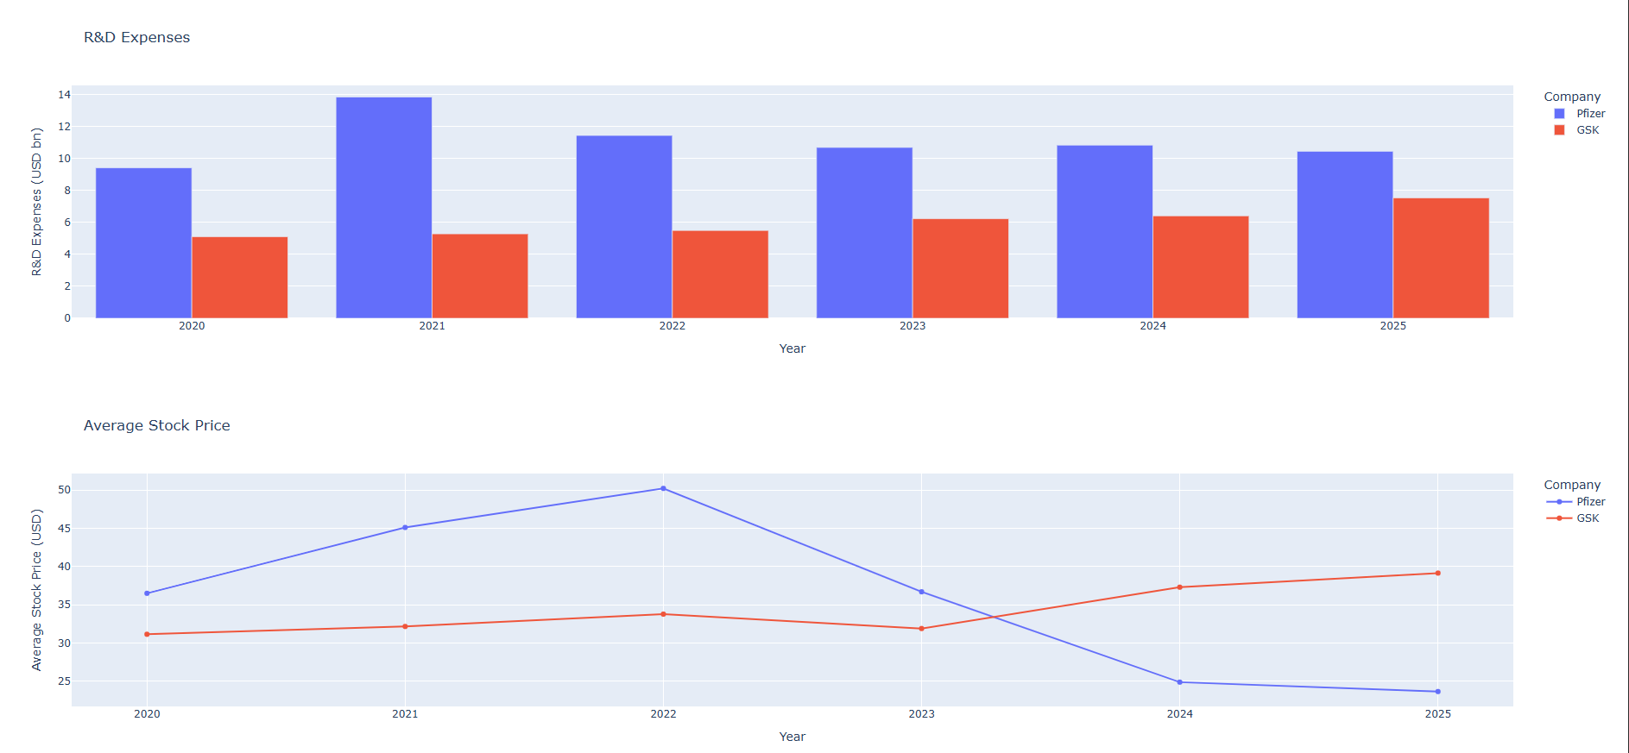
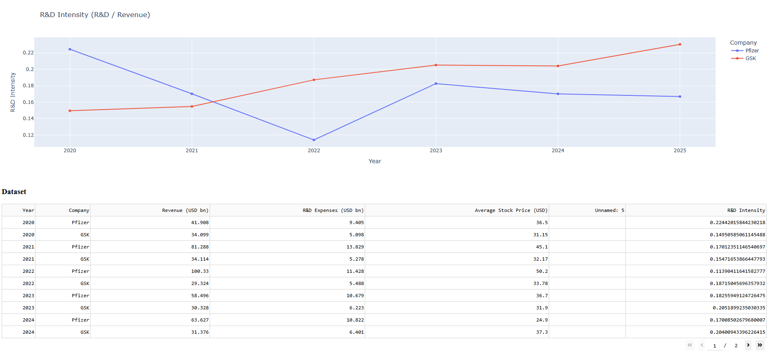
Appendix 2: Dashboard for Pharmaceutical Firms (Pfizer and GSK plc)

9.0 Dashboard Link

